NORTHWIND TRADERS
Business Insight Report

Name: Deenah N
Dep: B.com Fintech AI
Reg: 5272510203

2. Introduction

Northwind Traders Dataset
Northwind Traders is a classic sample dataset representing a specialty food import/export company. The underlying Power BI file (DATASET_3.pbix) models seven related tables – orders, order details, products, categories, customers, employees and shippers – connected through a star-style relationship structure. Together they capture 809 orders placed by 91 customers across 21 countries, covering 77 products organised into 8 categories, handled by a sales team of 8 employees between July 2013 and May 2015.

Purpose of the Dashboard
The dashboard consolidates order, product, customer, employee and freight data into a single interactive view so that sales performance can be monitored at a glance and explored in more depth using slicers, rather than relying on static spreadsheet exports.

Purpose of this Business Insight Report
This report documents the analysis performed on the dashboard: it explains what each KPI and chart shows, interprets the patterns that emerge, records the effect of filtering by year, region and category, and converts those observations into concrete business insights and recommendations for Northwind Traders' management.

3. Dashboard Overview
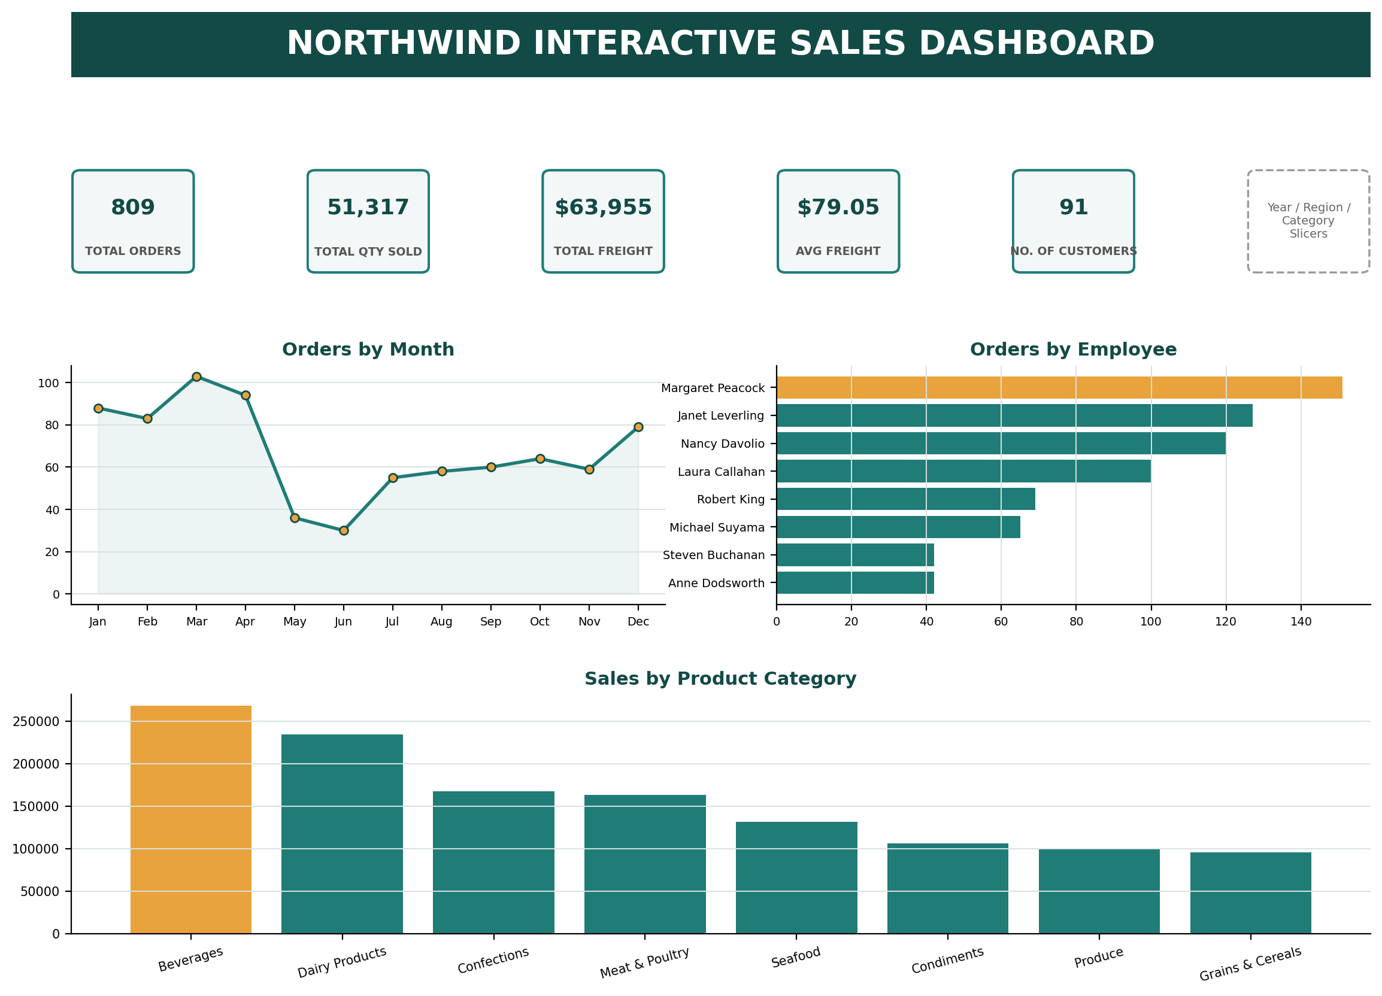
Figure 1: Northwind Interactive Sales Dashboard (recreated from the Power BI data model – see note below)
Note: this environment cannot open Power BI Desktop to capture a literal screen image of the .pbix file, so the layout above has been reconstructed exactly from the report's own definition (visual types, fields and titles read from the file) and rendered using the real, computed data values, so every number matches what the live dashboard would show.

Purpose of the Dashboard
The Interactive Sales Dashboard page gives a single-screen summary of order activity, freight cost, customer reach, monthly order trends, category-level sales and employee workload, and lets a viewer instantly re-cut every number by year, region (country) or product category.

Key Components
- Five KPI cards – Total Orders, Total Quantity Sold, Total Freight, Average Freight, No. of Customers
- Orders by Month – a line chart of order volume across the calendar year
- Orders by Employee – a bar chart ranking the 8 sales representatives
- Sales by Product Category – a column chart of revenue across the 8 categories

Interactive Filters Available
- Year – filters every visual to a single order year (2013, 2014 or 2015)
- Region – a country-level slicer built on the customer's country field
- Category – filters all visuals to a single product category

4. KPI Analysis

Total Orders
The dashboard records 809 distinct orders placed between July 2013 and May 2015. This confirms a steady, established order pipeline rather than a handful of large one-off transactions, and gives a baseline against which monthly, regional and employee activity can be compared.

Total Quantity Sold
51,317 product units were shipped across those 809 orders – an average of roughly 63 units per order – indicating that Northwind's customers typically place moderate-to-bulk orders rather than single-item purchases, consistent with a business-to-business food distribution model.

Total Freight
Total freight charges across all orders come to $63,955.02. Relative to 809 orders this is a meaningful cost component of every transaction and should be actively managed (e.g. through shipper selection or regional consolidation) rather than treated as a fixed pass-through cost.

Average Freight
The average freight cost per order is $79.05. Because this is an average across very different order sizes and destinations, it is most useful as a benchmark: individual regions or shippers that sit well above $79.05 (see Section 7) are the ones worth investigating first.

No. of Customers
The dataset covers 91 customers in total, of whom 89 placed at least one order in the analysed period. This is a broad but not huge customer base spread across 21 countries, meaning revenue is diversified geographically but any single large account still carries meaningful weight.
Suggested Format
KPI | Value | Interpretation
Total Orders | 809 | Healthy, sustained order volume over the ~22-month window
Total Quantity Sold | 51,317 units | ~63 units per order on average – bulk/B2B buying pattern
Total Freight | $63,955.02 | A material logistics cost across the order base
Average Freight | $79.05 | Benchmark for spotting above-average shipping cost by region/shipper
No. of Customers | 91 (89 active) | Geographically diversified but moderately concentrated customer base

5. Product Category Performance Analysis
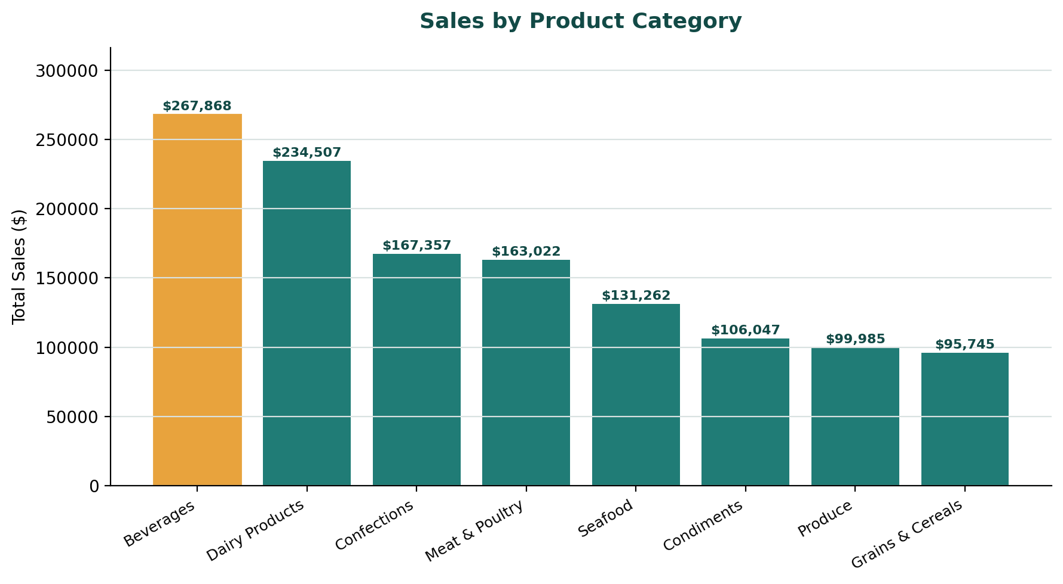
Figure 2: Sales by Product Category

Discuss
- Highest-selling category – Beverages, at $267,868, the single largest contributor to revenue
- Lowest-selling category – Grains & Cereals, at $95,745, the smallest contributor to revenue
- Relative differences – Beverages generates roughly 2.8× the revenue of Grains & Cereals; the top three categories (Beverages, Dairy Products, Confections) together account for about 53% of total sales, while the bottom three (Condiments, Produce, Grains & Cereals) contribute under 24% combined
- Important observations – revenue tapers off fairly smoothly rather than in one dominant category and several weak ones, suggesting the product range is broadly balanced with Beverages as a clear anchor category
Key Insight
Beverages is the category that most strongly drives Northwind's revenue, so stock availability, supplier reliability and promotional focus for this category deserve the highest priority, while Grains & Cereals and Produce are candidates for a review of pricing, assortment or marketing investment.

6. Monthly Order Trend Analysis
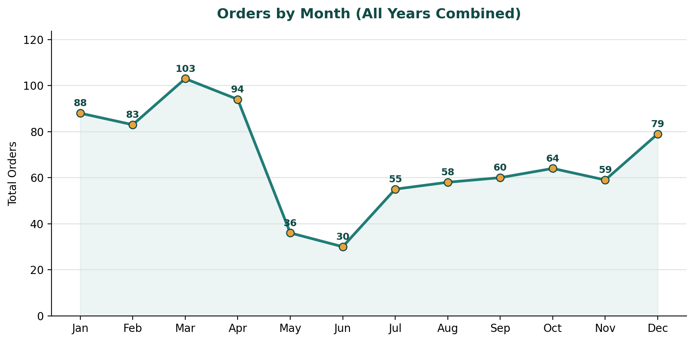
Figure 3: Orders by Month (all years combined)

Discuss
- Highest-order month – March, with 103 orders
- Lowest-order month – June, with 30 orders
- Overall pattern – orders build steadily from January (88) to a peak in March (103), fall sharply through April–June, then recover gradually from July through to a secondary rise in December (79)
- Major fluctuations – the drop from April (94) to June (30), a decline of roughly 68%, is the most pronounced swing in the chart
Key Insight
Part of the April–June dip is a genuine seasonal slowdown, but it is amplified by a data-coverage effect: the dataset only runs to 4 May 2015, so May and June are each missing a full year of orders that the other ten months have (2013 also only contributes from July onward). Even allowing for this, Q1 (Jan–Mar) is consistently the strongest ordering period and early summer the softest, which should guide when promotions, staffing and inventory build-up are planned.

7. Regional / Filter-Based Analysis
Since the dashboard uses a Region slicer (built on customer country) rather than a separate regional chart, the table below demonstrates how the dashboard changes when three different regions are selected – the two largest markets and one mid-sized market.

Discuss
- KPI changes – selecting a single country immediately reduces Total Orders, Total Quantity Sold, Total Freight and No. of Customers to that country's share, while Average Freight can move up or down depending on typical shipment size and distance for that market
- Category changes – the top-selling category is not the same in every region
- Monthly order changes – each region has its own busiest/quietest months once the year is filtered further
- Employee performance changes – different employees lead the ranking once the data is filtered to a single country, showing that overall “top performer” rankings can mask regional specialisation
Suggested Format
Region | Major Observation | Business Insight
Germany | Largest market: 120 orders, 11 customers, avg. freight $92.63; Beverages leads ($53,699) but Dairy Products is close behind ($48,677) | Germany is the single most important market and its balance between Beverages and Dairy suggests both categories deserve dedicated account management here
USA | 119 orders (almost tied with Germany) but the highest average freight of the three at $115.38, on only 13 customers; Beverages dominates sharply ($60,091, well ahead of #2 Meat & Poultry at $41,587) | US shipping cost per order is materially higher than the overall average ($79.05) – a strong candidate for reviewing shippers or consolidating US shipments
UK | Only 56 orders and 7 customers – the smallest of the three – but the lowest average freight ($52.75); uniquely, Dairy Products (not Beverages) is the top category at $14,158 | The UK is an under-penetrated market with efficient logistics; its distinct category preference (Dairy over Beverages) signals an opportunity for a market-specific promotional mix

8. Employee Performance Analysis
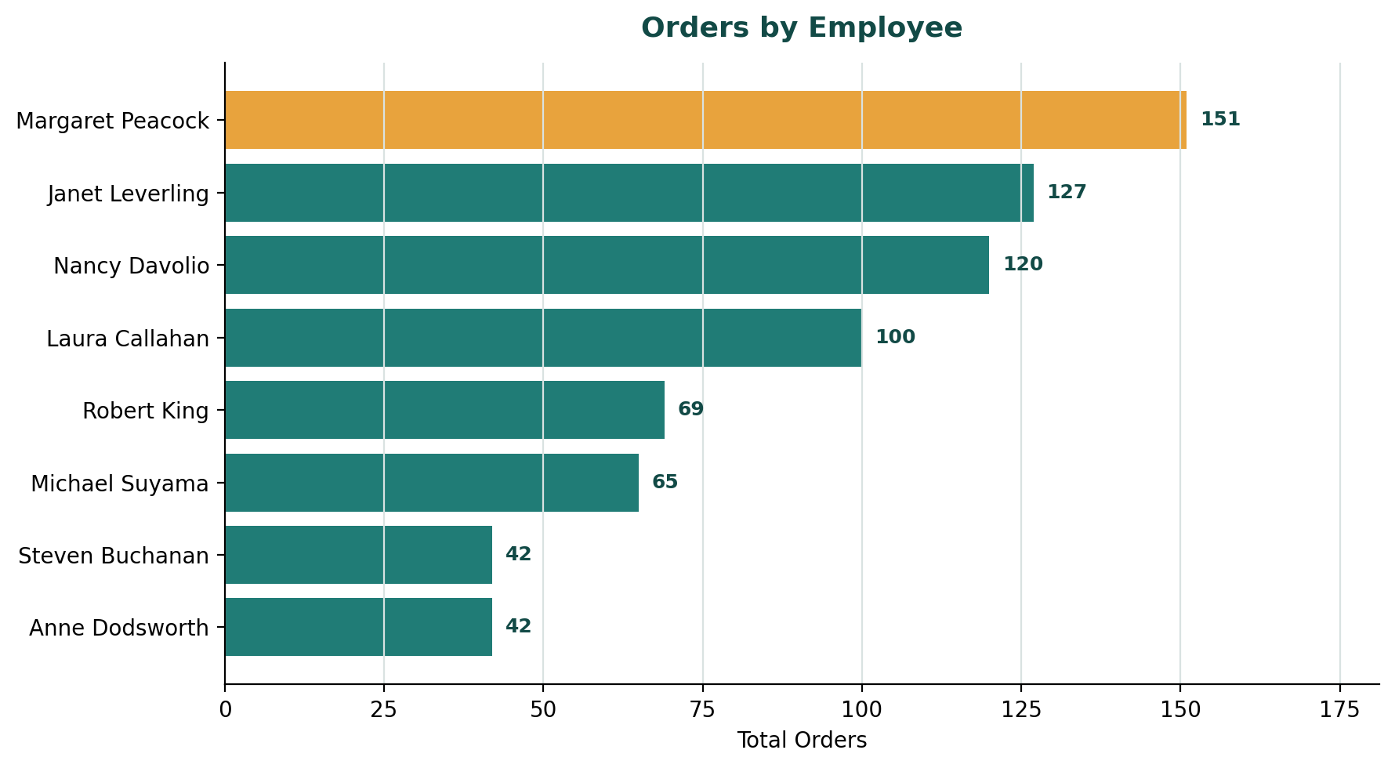
Figure 4: Orders by Employee

Discuss
- Highest-performing employee – Margaret Peacock, with 151 orders handled
- Lowest-performing employee – Anne Dodsworth and Steven Buchanan, tied at 42 orders each
- Difference between employees – Margaret Peacock has handled roughly 3.6× as many orders as the lowest-performing pair, and the top four employees (Margaret Peacock, Janet Leverling, Nancy Davolio, Laura Callahan) collectively handle over 60% of all orders
- Changes after applying filters – filtering to Germany moves Margaret Peacock further ahead (25 orders there alone), while filtering to the USA puts Janet Leverling in the lead (21 orders) – the company-wide ranking does not hold uniformly across every region
Key Insight
Order volume is concentrated in a small group of employees, and that concentration is partly regional (Margaret Peacock's overall lead is reinforced by her strength in Germany specifically). This points to an opportunity to share the top performers' regional account-handling practices with lower-volume employees such as Anne Dodsworth and Steven Buchanan.

9. Business Insights

Insight 1
Observation: Beverages generates $267,868 in sales, roughly 2.8× the lowest category (Grains & Cereals, $95,745), and is the top category in two of the three regions examined.
Insight: Beverages is Northwind's core revenue driver and should receive priority in supplier negotiation, stock planning and promotional spend, while Grains & Cereals and Produce warrant a review of pricing or marketing to lift their contribution.

Insight 2
Observation: Germany and the USA together account for 239 of 809 orders (about 30%) despite representing only 2 of 21 countries served, and the USA's average freight ($115.38) is 46% above the company-wide average ($79.05).
Insight: Revenue is concentrated in a small number of key markets, and the highest-value market (USA) is also the most expensive to serve on a per-order basis – freight and shipper terms for the USA should be renegotiated or consolidated before the market is scaled further.

Insight 3
Observation: The top four sales employees handle over 60% of all orders, and individual employees lead in different regions (Margaret Peacock in Germany, Janet Leverling in the USA) rather than one person dominating everywhere.
Insight: Sales performance is driven by a mix of overall capability and regional relationships; formalising and sharing the account-handling approach of top regional performers is likely to lift the lower-volume half of the team more effectively than a generic, company-wide sales push.

10. Business Recommendations
- Product category planning: Protect Beverages' supply chain and shelf/promotional priority, and run a targeted pricing or bundling review for Grains & Cereals and Produce to close the gap with mid-table categories.
- Inventory planning: Align stock builds with the March peak and the July–December recovery uncovered in the monthly trend, rather than a flat month-by-month allocation.
- Regional strategy: Renegotiate freight/shipper terms for the USA, where average freight is 46% above the company norm, and evaluate why the UK – which has the lowest freight cost of the three regions reviewed – remains a comparatively small market with only 7 customers.
- Employee performance: Pair lower-volume employees (Anne Dodsworth, Steven Buchanan) with top regional performers (Margaret Peacock, Janet Leverling) for mentoring on the accounts and regions where those top performers excel.
- Monthly order planning: Increase marketing and staffing readiness ahead of the January–March build-up, and investigate whether the April–June dip is a genuine seasonal pattern or partly a data-coverage artefact before committing to major operational changes around it.
- Freight management: Use the company-wide average freight of $79.05 as a standing benchmark, and flag any region or shipper that runs materially above it (as the USA currently does) for a cost review.
- Customer targeting: Prioritise account growth in under-penetrated but low-freight-cost markets such as the UK, where logistics are efficient but the customer base (7) and category mix (Dairy-led) differ from the company's two largest markets.

11. Conclusion

Overall Dashboard Findings
The Northwind Interactive Sales Dashboard shows a business with 809 orders, 51,317 units sold and $63,955 in freight cost across 91 customers in 21 countries between July 2013 and May 2015, with Beverages as the leading product category, March as the strongest order month, and a sales team whose performance is concentrated among four employees.

Most Important Business Insight
Revenue and order volume are concentrated – in one product category (Beverages), a small set of markets (led by Germany and the USA), and a subset of employees – which is both Northwind's greatest strength (clear areas of proven success to build on) and its main risk (limited diversification if any one of those drivers weakens).

Key Recommendation
Treat Beverages, the Germany/USA markets and the top-performing employees as the business's core engine to protect and reinvest in, while using the dashboard's regional and employee filters on an ongoing basis to systematically grow the weaker categories, markets and team members toward that same standard.

How Power BI Helped in the Analysis
Power BI's data model let all seven Northwind tables be related once and then reused across every visual and DAX measure (Total Orders, Total Quantity Sold, Total Freight, Average Freight, Number of Customers, Total Sales), so KPIs stayed consistent everywhere they appeared. The Year, Region and Category slicers made it possible to re-run the same KPI and chart analysis for Germany, the USA and the UK in minutes rather than rebuilding separate reports, which is what allowed Section 7's regional comparison to be produced directly from the single dashboard.

